

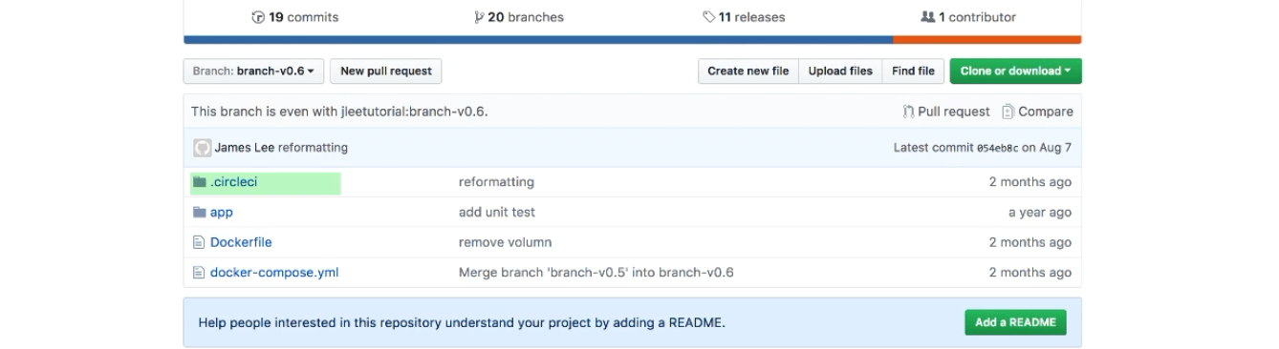

The circle ci build step are define in .circleci, cái này nằm ở đường dẫn root

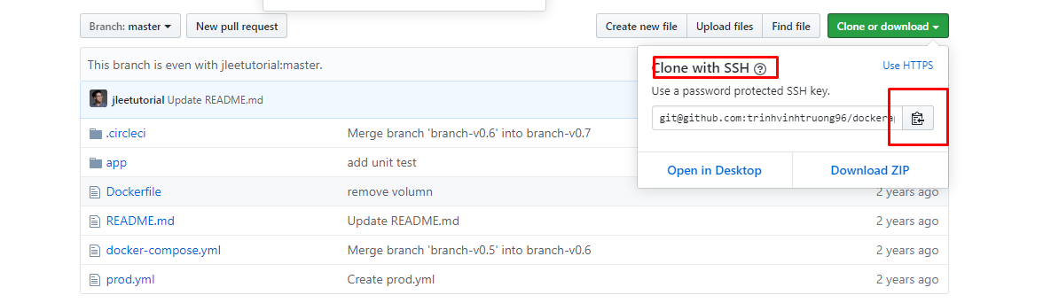

 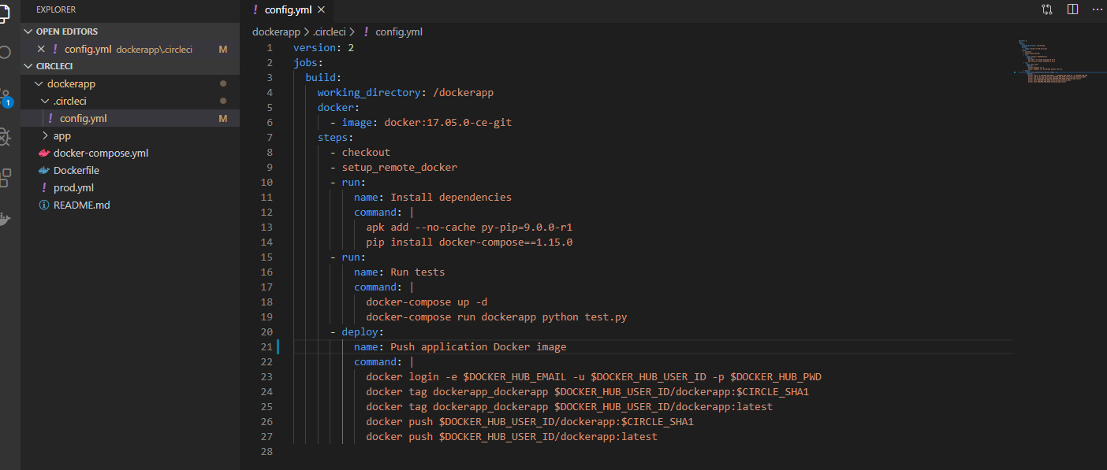



Primary container images for the jobs under docker

Define the circle enviroment: all the test will be running inside container and in this container we spin up out docker app as redis container and run our test so basicly it’s the container inside container( docker in docker)

Define the ci enviroment which is the outside container which is a docker image install docker and has git

and it’s here,

Khi image has surfix –git : means git be installed

Using this image ensure always using latest docker client



Check out source code from github to the working directory we already define



To build docker image for deployment -> create separated enviroment để remote run lênh vuốt vuốt các thứ

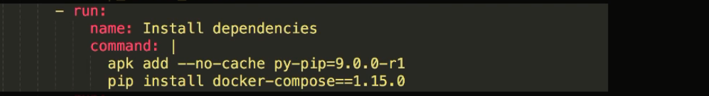

Install docker-compose in the ci enviroment through a python base using pip

Dòng trên dòng install là để install pip

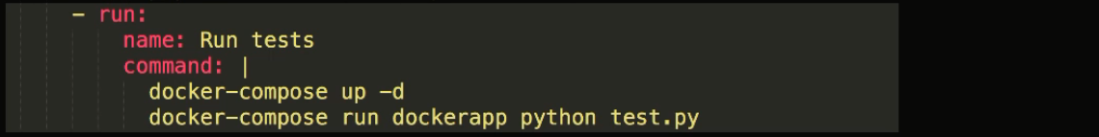

Run container và chạy test trong container như những bài trước đã làm

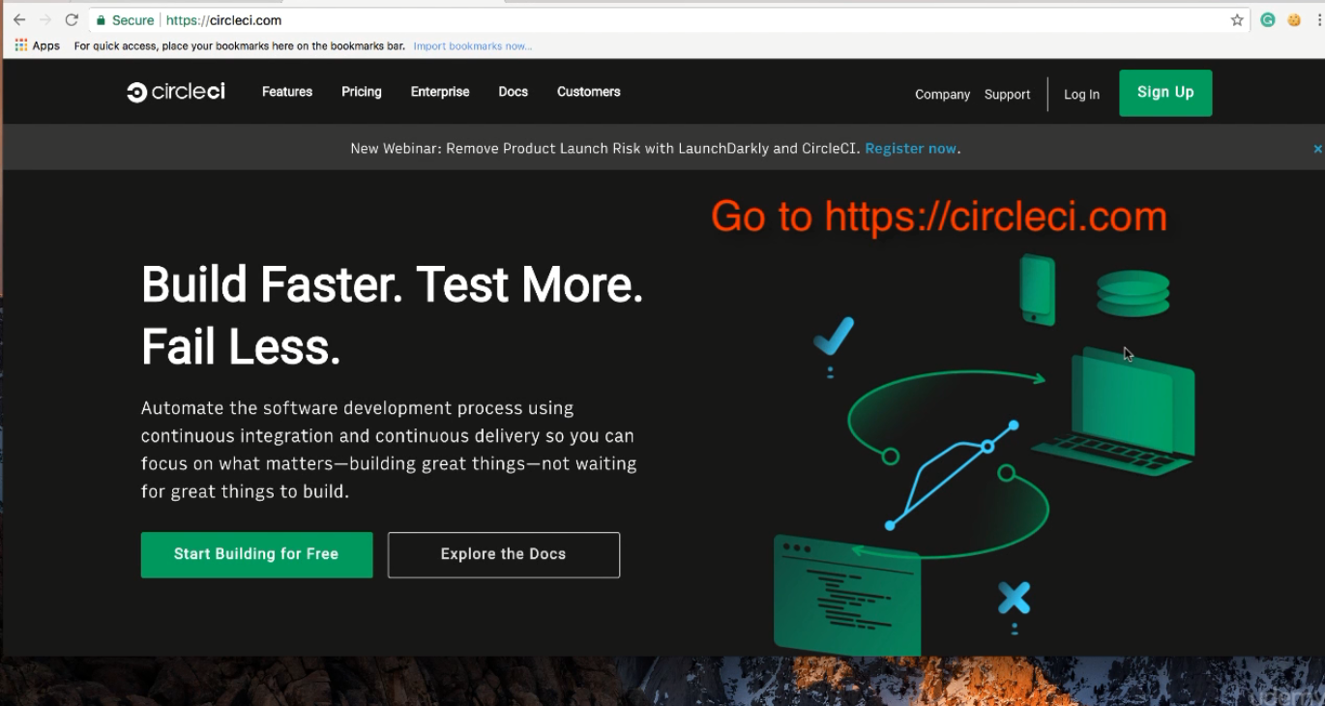

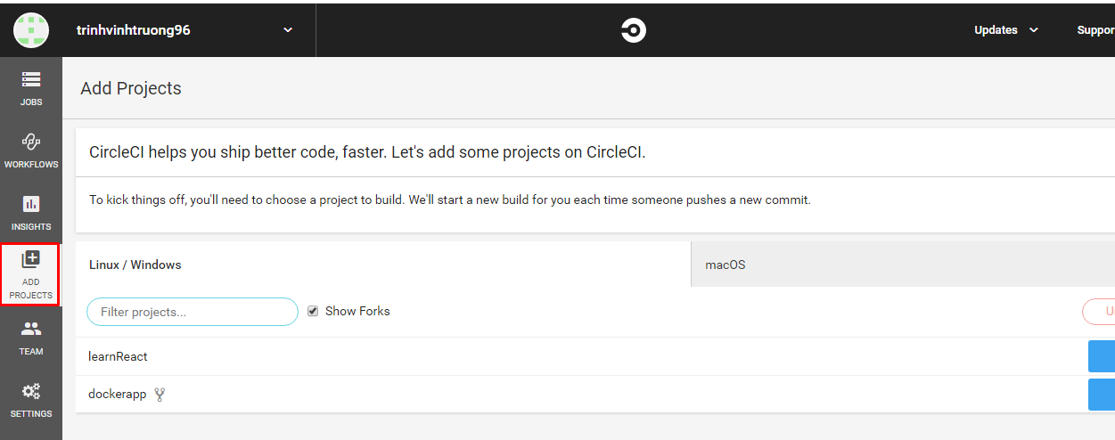 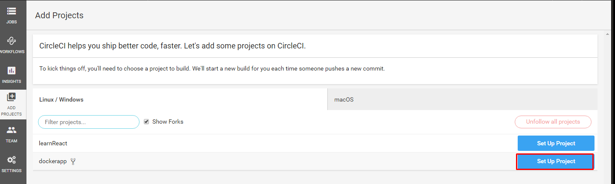

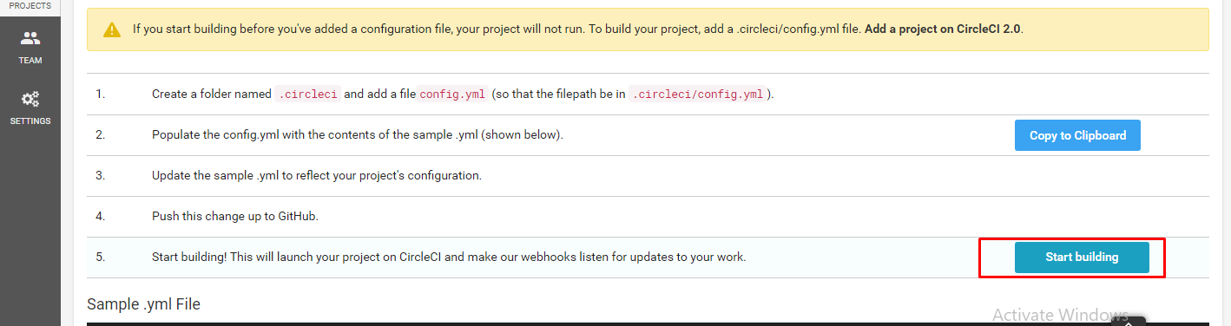

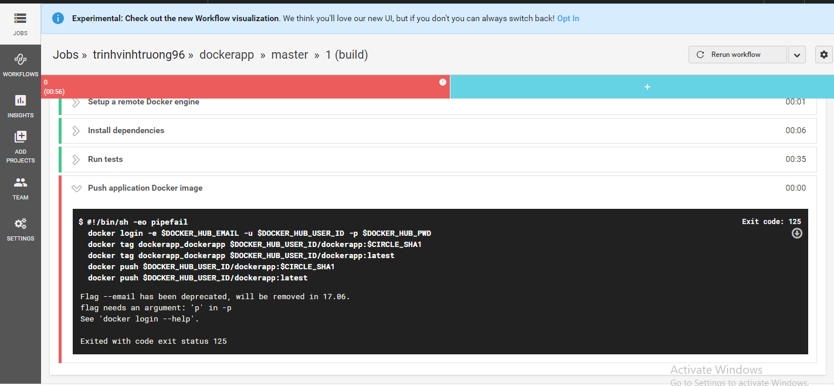

Build fail tèo téo teo

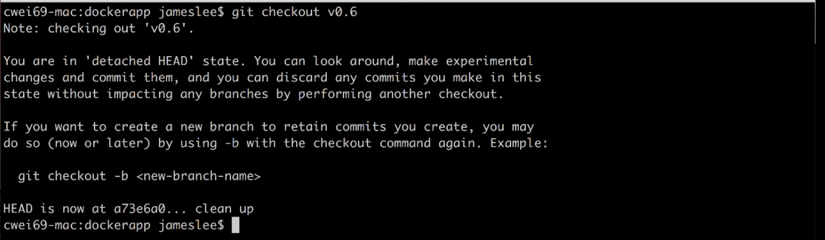

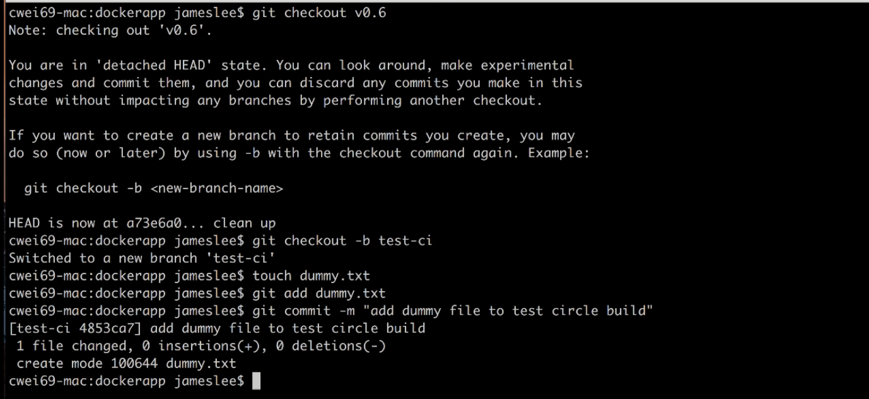

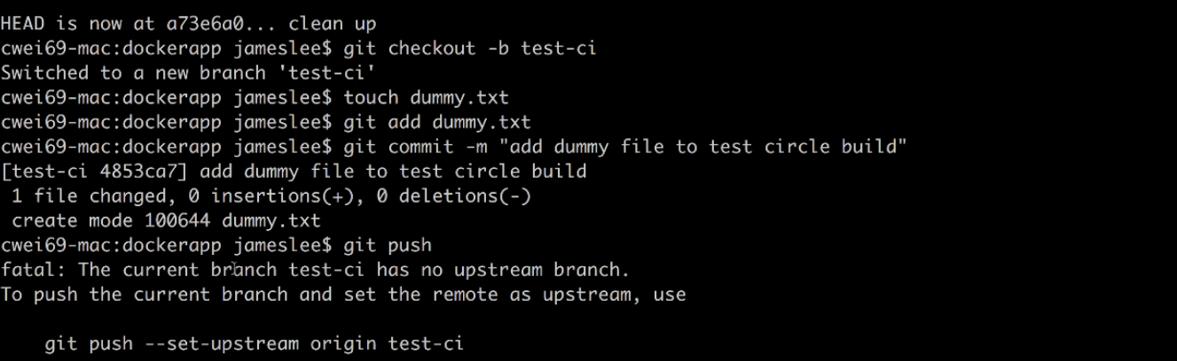



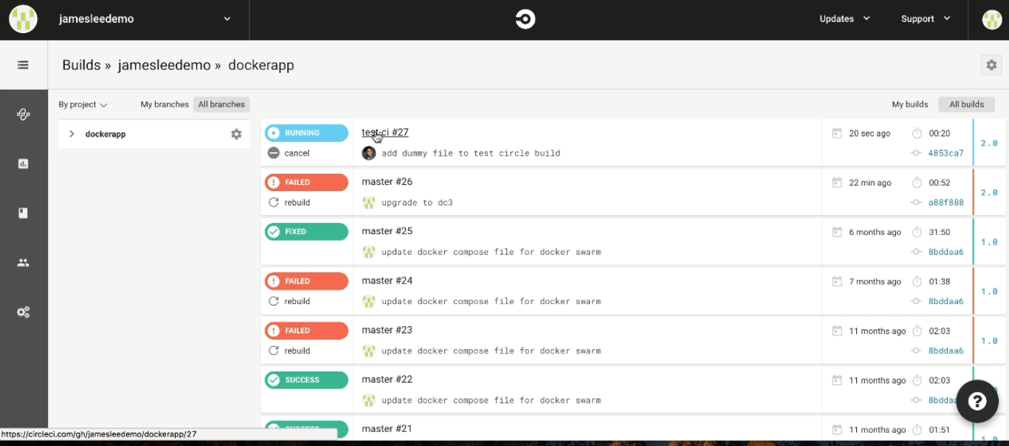

New build running ngay khi push, và nó chạy success

Khi nào có new change push to github thì trigger build trên circleci